**HOME, ABOUT, RESUME, PORTFOLIO**

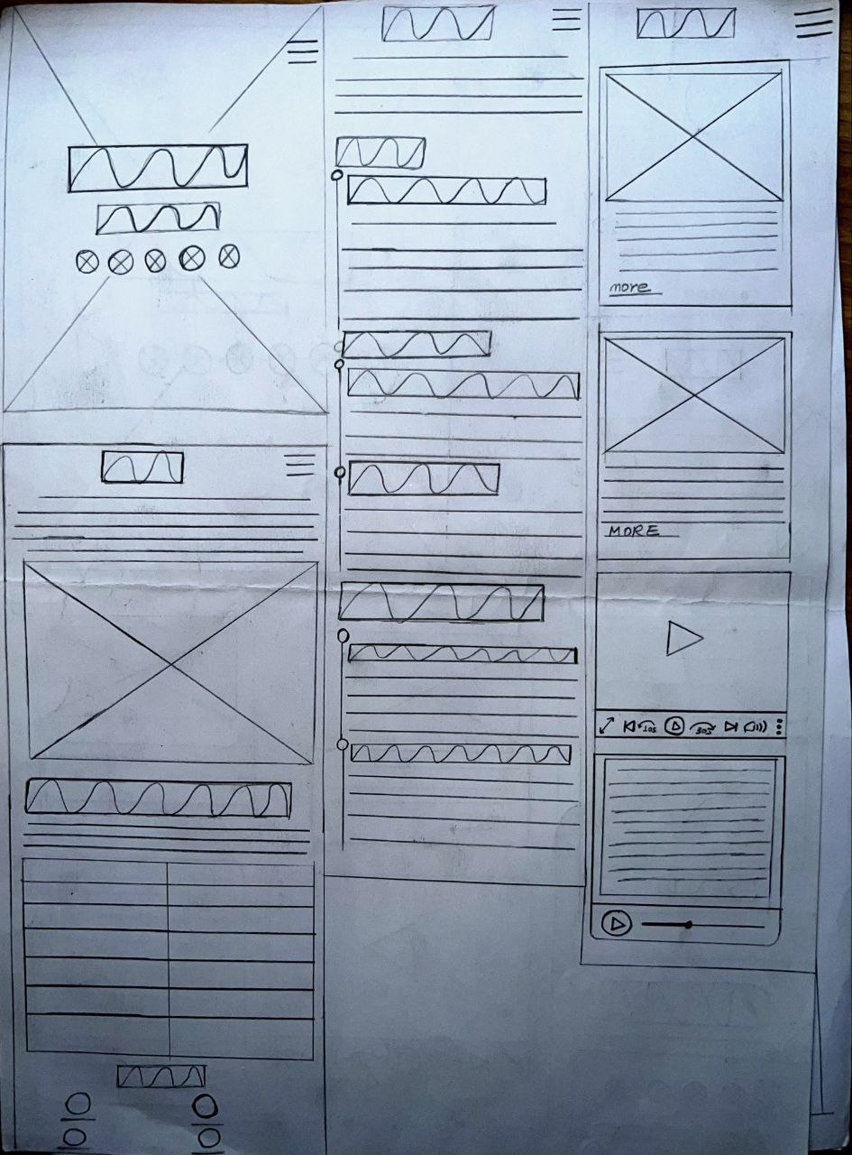

**TESTIMONIALS, CONTACT, FOTTER**

